SQUASH TF INTELLIJ
Plugin Development
Instruction for Working Environment settings

August 2019
Version 1.0.3

Document Revisions

Date | Version Number | Document Changes
31/07/2019 | 0.1 | Initial Draft
19/09/2019 | 0.2 | Update value for “tools.sourceDirectory” parameter
14/10/2019 | 0,3 | Added a warning for the maven path

- Download and install IntelliJ IDEA Community IDE into local if not existed (by default, it is in “C:\Program Files\JetBrains”). Version recommended: 2018.3.2.

- Get IntelliJ IDEA CE source code on your local computer by following these instructions up to (including) the IntelliJ Build Configuration section. Version recommended: 2018.3.2 (if cannot find in JetBrains git repository, contact Squash TF Dev group for sharing code source).

- Plugin DevKit plugin must be enabled in IntelliJ IDEA Community IDE.

- Download grammar-kit and IDEA-IC code source. Unzip IDEA-IC code source and put both the unzipped folder AND the grammar-kit-2017.1.7 in the same folder of your choice. For example:

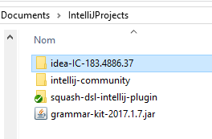

- Create a new IntelliJ Platform SDK under File | Project Structure:

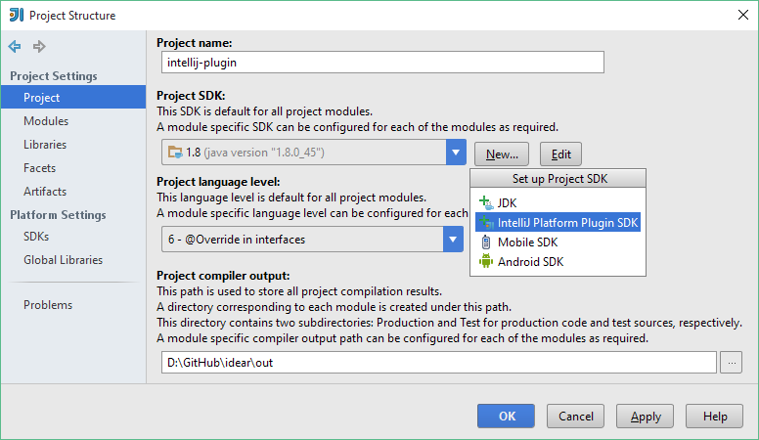

- Specify the folder of IDEA-IC code source as the home directory:

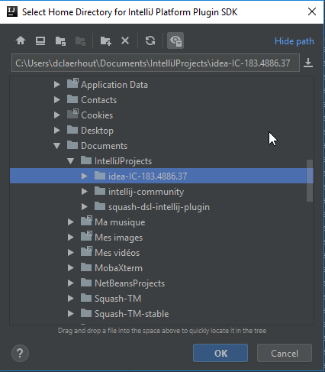

- Select 1.8 as the default Java SDK:

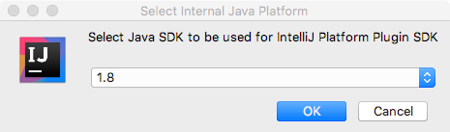

- In the Sourcepath tab of the SDK settings, click the Add button:

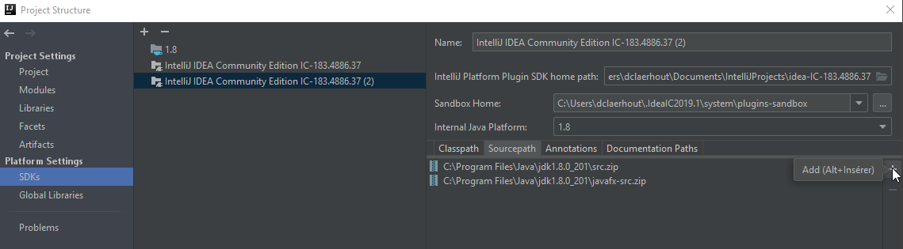

- Specify the source code directory for the IntelliJ IDEA Community Edition (downloaded in step 3):

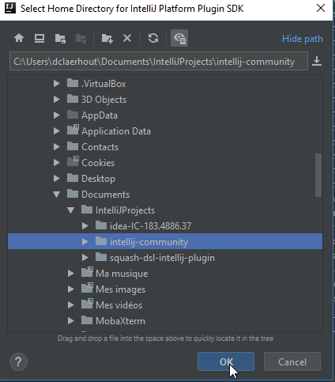

- Clone the Squash DSL IntelliJ plugin project code source, or do the checkout to get its latest version if existed.

- Download Maven-3.5.0

- Launch the IntelliJ IDE, in the menu File/Open, get to the Squash DSL IntelliJ plugin project. (If an extra configuration setting is required, choose the option “ipr” file)

- In the menu File/Settings, choose (or find with search bar) the Build, Execution, Deployment section, in Build Tools/Maven/Runner, check the option: “Delegate IDE build/run actions to maven”, then in the VM Option input box, insert:
-Dplatform.directory="path to your IDEA-IC code source "
-Didea.cfg.root= "path to your .IdeaIC folder"
-Dtools.sourceDirectory="path to the maven-3.5.0"

For example:
-Dplatform.directory="C:\Users\qtran\Desktop\squash-tf\idea-IC-183.4886.37"
-Didea.cfg.root="C:\Users\qtran\.IdeaIC2018.3"
-Dtools.sourceDirectory="C:\Users\qtran\Desktop\tools\maven-3.5.0"

Warning : The Maven path MUST contain NO spaces to avoid installation problems.
In the menu File/Project Structure, go to the Project Setting/Modules section, choose the squash-tf-intellij-plugin module, in the Dependencies tab, choose the IntelliJ IDEA Community Edition IC… in the Module SDK option.
If you don’t have that option in the choice box, please refer to step 5.
- In the IntelliJ IDE/Project Explorer of the squash-ta-intelliJ-reactor project, open the plugin/squash-tf-intellij-plugin.iml file, replace the XML property:

type= "JAVA_MODULE"
by type ="PLUGIN_MODULE"

Wait for the modification charging until the plugin module icon updates:

- Add an execution configuration: Click on the “Add configuration…” button on the top right screen of the IntelliJ IDE
- In Templates, choose Plugin type. In “”Before launch”: choose option “Build project”. Apply.
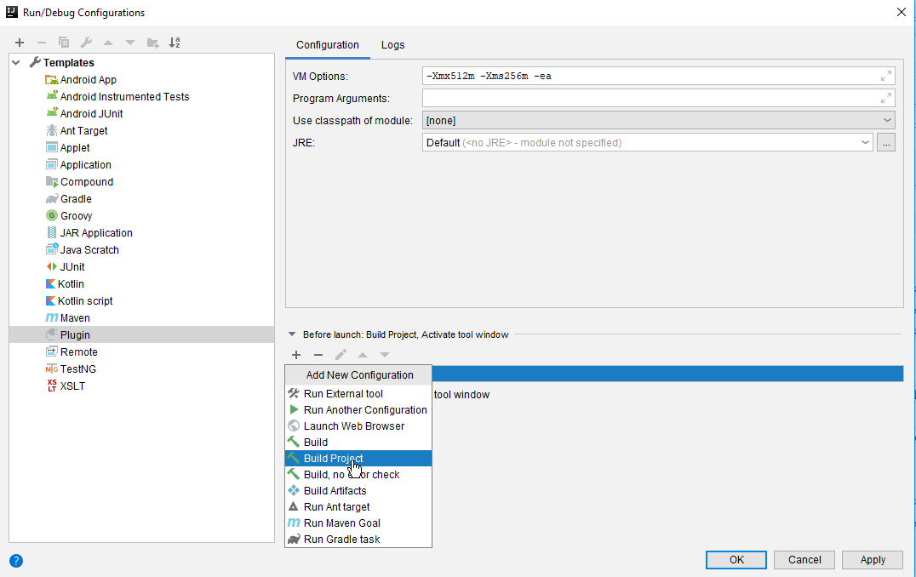

- Launch the build, normally an IntelliJ IDE with integrated Squash DSLs will be created.
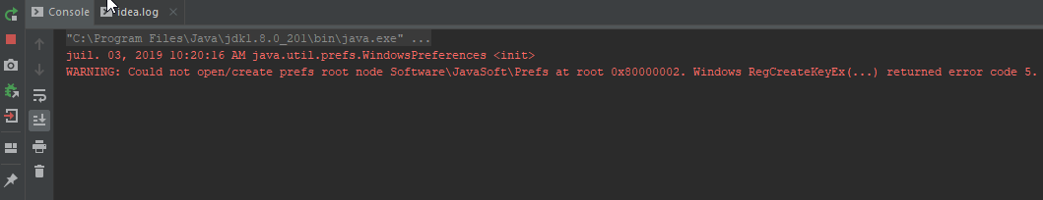
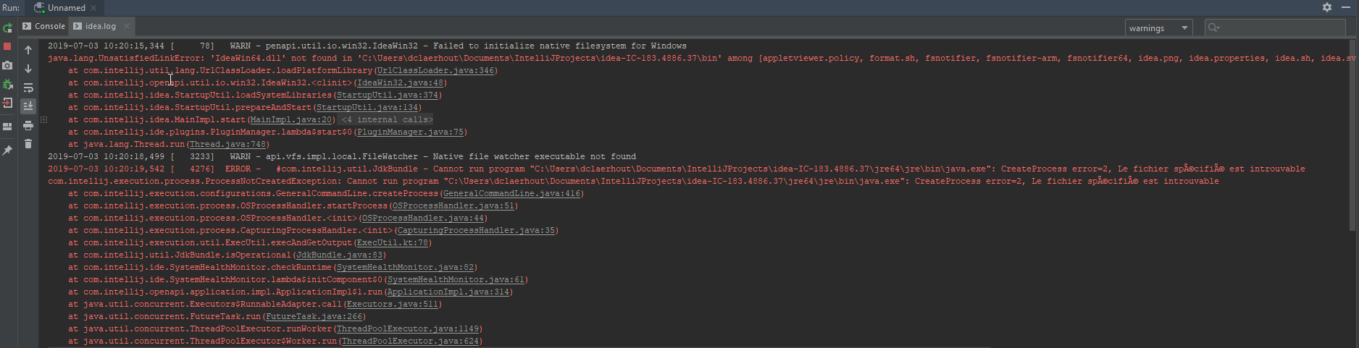
If you encounter the following error message, do not take it into account, it is not important:

